**VIVA VOCE QUESTIONS FOR OPERATING SYSTEM**

**1. What is the short cut command to open local users and groups console.**

**Answer. Open Run**

**Type Lusrmgr.msc**

**2.** What is the DOS command for enabling the user account in Windows NT OS.

Answer. **net user username /active**

**3. Write a batch file for copying filenames of all the files in a folder**

**Answer. @echo off**

**dir /b > red.txt**

**4. Explain how to access Terminal in linux?**

Answer. To access terminal, you have to go under Application **Menu -> Accessories -> Terminal.**

**5. how to Reset Admin user in Redhat linux**

TO RESET ADMIN (ROOT) PASSWORD in REDHAT

TO RECOVER THE ADMIN PASSWORD – ENTER INTO RUNLEVEL 1

(RUNLEVEL 1 – FOR TROUBLESHOOTING)

Step 1:- Reboot the System and Press spacebar or Esc key

continuously

Step 2:- On the OS Name Press ‘E’ to Enter

Step 3:- Select Kernel & Press ‘E’ to enter

Step 4:- Give space after quite and type 1 & press ‘B’ for boot

Step 5:- Disable the SE-LINUX firewall

# setenforce 0

Step 6:- Assign the New Password

# passwd root

Password: redhat

Re-Password: redhat

Step 7:- Reboot the System & Check the Result

init 6 or reboot

**6. How to scan folder with antivirus in Linux?**

Answer: Applications → Security → Clamtk

in Application Window, double click on the **Scan a directory,** Select the folder you want to

scan.

**7. How to change user password**

A: Press Super key(Window Key) and search for Settings.

Open Setting -> Users -> unlock -> Click on existing password. Enter your current password

and twice your new Password.

**8. How to check last update (patches,application soft and OS) in client 6.1 and boss**

**server**

A: Click on Application -> Utilities -> System Log -> give admin password -> click

authentication -> new box of system log will open -> click on the setting (gear icon) -> click

on open -> select APT -> select the history log-> open windows will show all updates history

**9. How to solve Error Explorer.exe has encountered a problem and needs to close”**

Solution

1. CTRL-Alt-Del to bring up Task Manager.

2. Click File | New Task (run).

3. Type regedit in the Run box and click OK.

4. Browse to the following registry key:

HKEY_LOCAL_MACHINESOFTWARE/MicrosoftWindowsNT/CurrentVersionImageFileExecution.options/

Under this key there will be sub keys named explorer.exe and iexplorer.exe. Delete the explorer and iexplorer keys entirely. They should not be listed under the ImageFileExecution.Optionskey.

If Explorer.exe is not automatically loading when windows start then change the following registrykey: HKEY_LOCAL_MACHINESOFTWARE/MicrosoftWindowsNT/ CurrentVersion/ WINLOGON

In Winlogon, on the right side, there should be a value called "Shell". Double click this value. Make sure only 'Explorer.exe' is the value of Shell, if anything else is there, simply delete it and leave 'Explorer.exe'.

Close the Registry Editor.

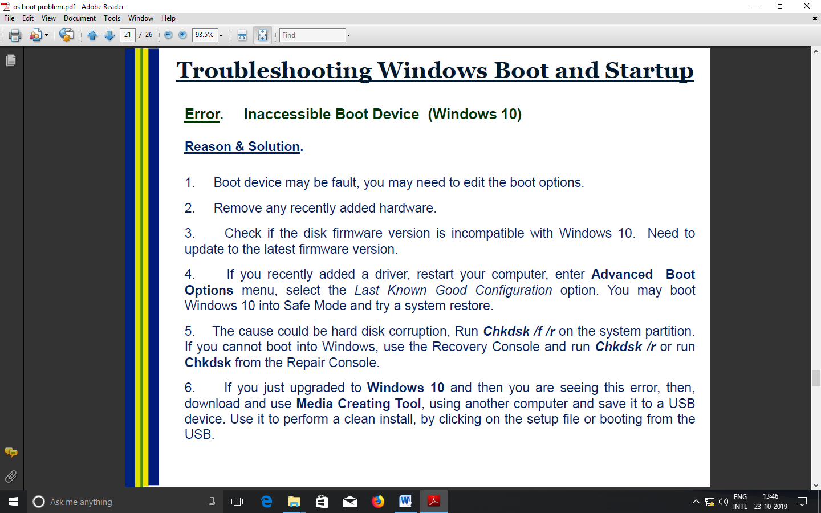**10. How to solve Error** Inaccessible Boot Device (Windows 10)